COMP 333 Practice Exam

This is representative of the kinds of topics and kind of questions you may be asked on the midterm.

Higher-Order Functions in JavaScript

1.) Write the output of the following JavaScript code:

function foo(fooParam) {
return function (innerParam) {
return fooParam - innerParam;
}
}

let f1 = foo(7); // fooParam = 7 for f1
let f2 = foo(10); // fooParam = 10 for f2
console.log(f1(2)); // innerParam = 2 for f1; 7 - 2 = 5
console.log(f2(3)); // innerParam = 3 for f2; 10 - 3 = 7
console.log(f1(4)); // innerParam = 4 for f1; 7 - 4 = 3
console.log(f2(5)); // innerParam = 5 for f2; 10 - 5 = 5

5
7
3
5

2.) Consider the following JavaScript code:

function base() {
return function (f) {};
}

function rec(n) {
return function (f) {
f();
n(f);
}
}

function empty() {}

let f1 = rec(rec(base()));
let f2 = rec(rec(rec(base())));
f1(empty);
f2(empty);

How many times is empty called in total in the above code?

5

3.) Consider the following JavaScript code with corresponding output, which calls an unseen function called mystery:

function output() {
console.log("foo");
}

let f1 = mystery(output);
f1();
console.log();

let f2 = mystery(f1);
f2();
console.log();

let f3 = mystery(f2);
f3();
console.log();

Output:
foo
foo

foo
foo
foo
foo

foo
foo
foo
foo
foo
foo
foo
foo

Define the mystery function below.

function mystery(f) {
return function() {
f();
f();
};
}

4.) Write the output of the following JavaScript code:

// returns a function that will bound the output of the wrapped
// function, so the output is never less than min or greater than
// max
function cap(min, max, wrapped) {
return function (param) {
let temp = wrapped(param);
if (temp < min) {
return min;
} else if (temp > max) {
return max;
} else {
return temp;
}
};
}

function addTen(param) {
return param + 10;
}

function subTen(param) {
return param - 10;
}

let f1 = cap(0, 10, addTen);
let f2 = cap(0, 100, addTen);
let f3 = cap(0, 10, subTen);
let f4 = cap(0, 100, subTen);

console.log(f1(0));
console.log(f1(5));
console.log();

console.log(f2(0));
console.log(f2(5));
console.log();

console.log(f3(0));
console.log(f3(5));
console.log();

console.log(f4(0));
console.log(f4(5));
console.log();

10
10

10
15

0
0

0
0

5.) Consider the following JavaScript code and output:

console.log(
ifNotNull(1 + 1,
a => ifNotNull(2 + 2,
b => a + b)));
console.log(
ifNotNull(7,
function (e) {
console.log(e);
return ifNotNull(null,
function (f) {
console.log(f);
return 8;
})
}));

Output:
6
7
null

ifNotNull takes two parameters:
- Some arbitrary value, which might be null
- A function. This function is called with the arbitrary value if the value is not null, and the result of the function is returned. If the value is null, this function isn't called, and null is returned instead.

Define the ifNotNull function below, so that the output above is produced.

function ifNotNull(value, f) {
if (value !== null) {
return f(value);
} else {
return value;
}
}

6.) Consider the following array definition in JavaScript:

let arr = [0, 1, 2, 3, 4, 5, 6, 7, 8, 9, 10]

6.a) Use filter to get an array of all even elements in arr.

// filter takes a function that takes an element and returns true
// if the element should be in the returned array, else false
arr.filter(e => e % 2 === 0)

// alternative answer
arr.filter(function (element) {
return element % 2 === 0;
})

6.b) Use map to get an array of strings, where each string represents a number in arr. As a hint, you can call the toString() method on a number (e.g., 5.toString()) in JavaScript to get its string representation.

// map takes a function that takes an element and returns the
// corresponding value which should be in the output array
arr.map(e => e.toString())

// alternative answer
arr.map(function (element) {
return element.toString()
});

6.c) Use reduce to get the last element in arr.

// reduce takes a function that takes an accumulator and an element,
// and returns the value of the new accumulator. In this case, reduce
// is only given the function, so it will use the first array element
// as the initial accumulator, and start iterating from the second
// array element
arr.reduce((accum, element) => element)

// alternative anser
arr.reduce(function (accum, element) {
return element;
})

6.d) Use a combination of filter and reduce to get the sum of all elements in arr which are greater than 5.

// this use of reduce uses an explicit starting accumulator of 0
arr.filter(e => e > 5).reduce((accum, element) => accum + element, 0)

// alternative answer
arr.filter(function (e) { return e > 5 })
.reduce(function (accum, element) { return accum + element }, 0)

Prototype-Based Inheritance in JavaScript

7.a.) Define a constructor for Dog objects, where each Dog object has a name. An example code snippet is below, illustrating usage:

let d = new Dog("Rover"); // line 1
console.log(d.name); // line 2; prints Rover

// From line 1, we need a Dog constructor that takes one parameter.
// From line 2, the constructor must be setting the name field of
// Dog objects to the parameter.
function Dog(param) {
this.name = param;
}

7.b.) Define a different constructor for Dog, which puts a bark method directly on the Dog objects. The bark method should print "Woof!" when called. Example usage is below:

let d = new Dog("Sparky");
d.bark(); // prints Woof!

function Dog(name) {
this.name = name; // not explicitly required based on the question
// bark is directly on created Dog objects, as opposed to being
// on the prototype chain for Dog objects
this.bark = function() { console.log("Woof!"); }
}

7.c.) Define a method named growl for Dog objects, which prints "[dog name] growls" when called. Use Dog's prototype, instead of putting the method directly on Dog objects themselves. Example usage is below:

let d = new Dog("Rocky");
d.growl(); // prints Rocky growls

Dog.prototype.growl = function() {
// assumes constructor initializes this.name, as with 3.a
console.log(this.name + " growls");
}

8.) Consider the JavaScript code below:

function Animal(name) { this.name = name; }
Animal.prototype.getName = function() { return this.name; }
function Bird(name) { Animal.call(this, name); }
Bird.prototype = Object.create(Animal.prototype);
Bird.prototype.fly = function() {
console.log(this.getName() + " flies");
}
function Mouse(name) {
this.name = name;
this.squeak = function() {
console.log(this.name + " squeaks");
}
}
Mouse.prototype = Object.create(Animal.prototype);
Mouse.prototype.fly = Bird.prototype.fly;
let b1 = new Bird("Coco"); let b2 = new Bird("Sunny");
let m1 = new Mouse("Pip"); let m2 = new Mouse("Ruby");

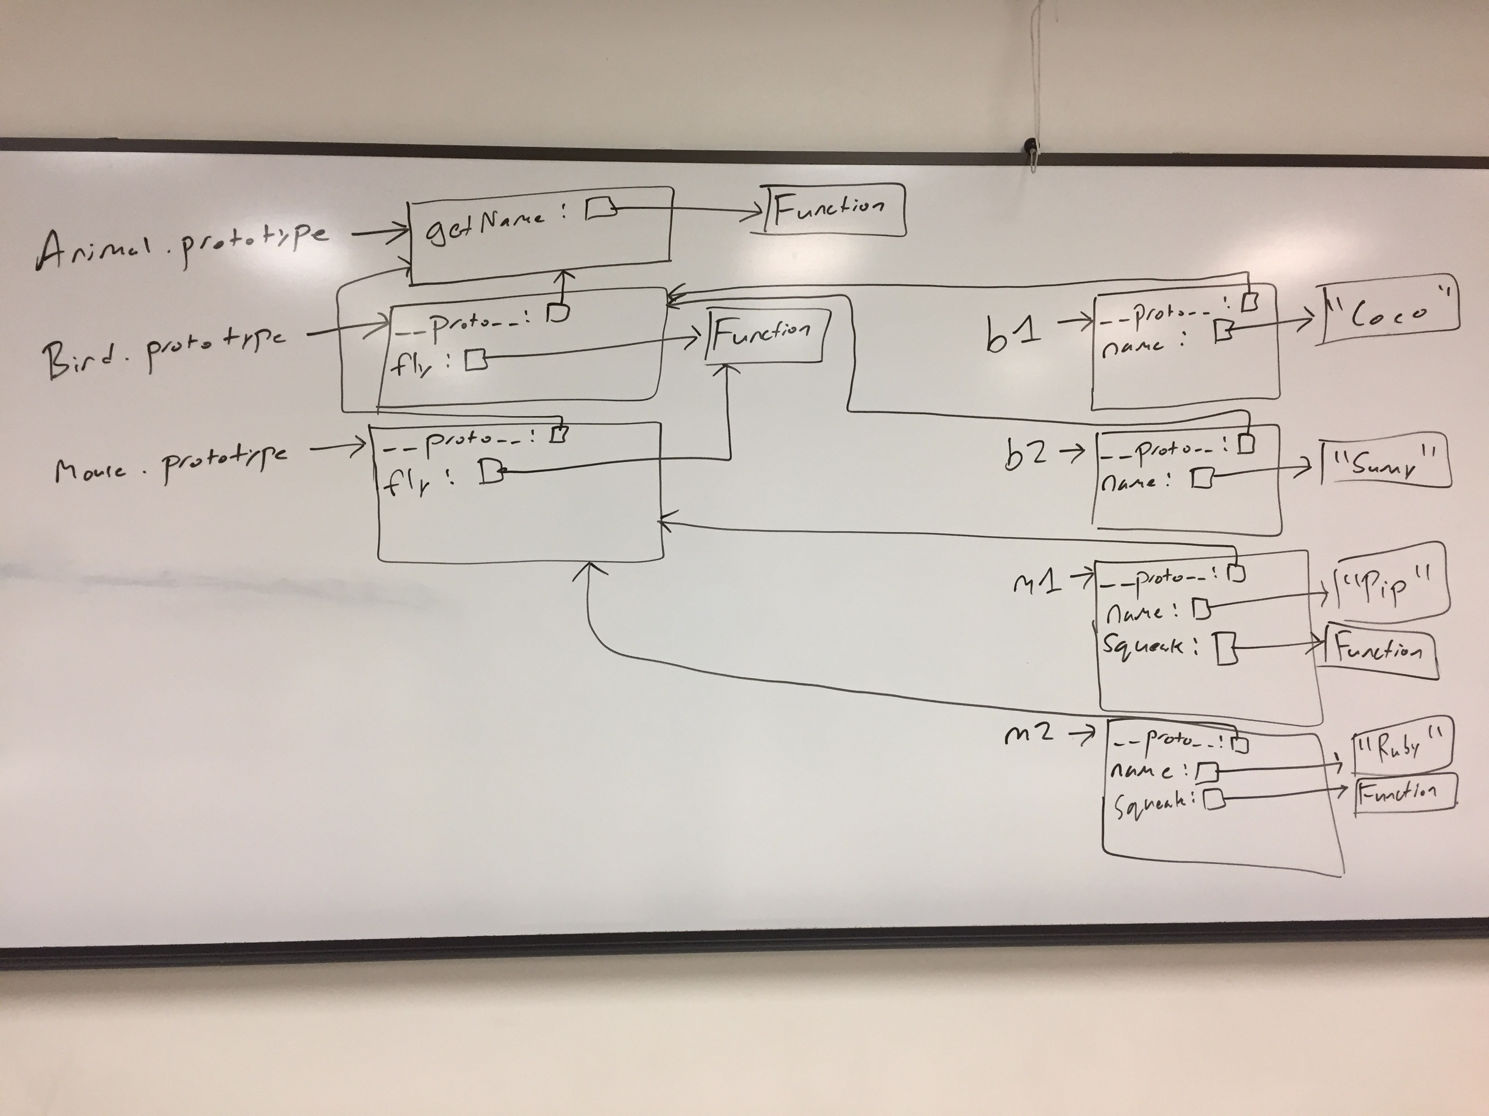
Write a memory diagram which shows how memory looks after this program executes. Your diagram should include the objects and fields associated with b1, b2, m1, m2, Mouse.prototype, and Bird.prototype, Animal.prototype. As a hint, the __proto__ field on objects refers to the corresponding object's prototype.
9.) Consider the test suite below, using assertEquals from the second assignment:

function test1() {
let t1 = new Obj("foo");
assertEquals("foo", t1.field);
}

function test2() {
let t2 = new Obj("bar");
assertEquals("barbar", t2.doubleField());
}

function test3() {
let t3 = new Obj("baz");
// hasOwnProperty returns true if the object itself has the field,
// otherwise it returns false. If the field is on the object's
// prototype instead (__proto__), it returns false.
assertEquals(false, t3.hasOwnProperty("doubleField"));
}

Write JavaScript code which will make the above tests pass.

// Object is a built-in in JavaScript, but not Obj. This requires a
// custom constructor. From test1, we know that Obj must be a
// constructor, and that Obj objects need a field named "field". The
// value of this field must be equal to whatever its parameter is.
function Obj(param) {
this.field = param;
}

// From test2, we know that we need a doubleField method on Obj
// objects. From test3, we know that doubleField cannot be directly
// on the Obj objects, so we must put it on Obj's prototype.
Obj.prototype.doubleField = function() {
// + in this context performs string concatenation; this
// concatenates this.field onto itself
return this.field + this.field;
}

Language Concepts

10.) In regards to memory management, Swift and Python (specifically cpython) both use reference counting, whereas Java and JavaScript both use garbage collection.

10.a.) In 1-3 sentences, in your own words, explain how garbage collection reclaims memory. Your description doesn't have to be detailed enough to implement a garbage collector, only detailed enough to get the gist of when memory would be reclaimed.

Starting from all variables declared on the stack (or globally), we trace through memory and determine which parts of memory are reachable or not. The parts of memory which are not reachable are reclaimed.

10.b.) In 1-3 sentences, in your own words, explain how reference counting reclaims memory. Your description doesn't have to be detailed enough to implement reference counting, only detailed enough to get the gist of when memory would be reclaimed.

Each allocated chuck of memory is given a reference count, which is incremented whenever a new reference is made to this memory, or decremented whenever an existing reference disappears. If the reference count hits zero, the memory is reclaimed.

10.c.) Name one advantage of reference counting over garbage collection.

Possible answers, among others:
- Memory is generally reclaimed as soon as it is no longer needed
- Happens at much more predictable times than garbage collection
- Application performance tends to be much more consistent than with garbage collection

10.d.) Name one advantage of garbage collection over reference counting.

Possible answers, among others:
- Can reclaim cyclic data structures without programmer intervention
- Generally better performance in terms of lower overall execution times

11.) In 1-3 sentences, explain the difference between compilation and interpretation. Your answer does not need to be detailed enough to implement a compiler or interpreter.

Compilers translate programs written in one programming language to another, whereas interpreters directly execute programs written in a given programming language.

12.) The Java Virtual Machine (JVM) is implemented as an interpreter over Java bytecode. Similarly, most JavaScript implementations are implemented as interpreters. However, most Java and JavaScript implementations support just-in-time (JIT) compilation.

12.a.) In 1-3 sentences, explain what JIT compilation does, in the context of an interpreter. Your answer doesn't need to be detailed enough to implement a JIT compiler.

The interpreter dynamically monitors code and can choose to compile chunks of frequently-executed code directly to machine code. When these chunks are executed in the future, it can jump to the compiled chunks of machine code as opposed to interpreting the corresponding original code.

12.b.) JIT compilers can sometimes generate faster code than traditional compilers. Why?

Traditional compilers can only reason about how code might execute, whereas JIT compilers can observe exactly how code is executed. As such, the JIT compiler has more information to work with, and can use this to generate faster, more optimal code.

13.) Swift, Scala, and Haskell all support type inference. In 1-3 sentences, explain what type inference is, and how it relates to statically-typed and dynamically-typed languages. You don't have to provide enough detail to implement a type inferencer.

Type inference allows a compiler for a statically-typed language to infer what the types of variables must be, without the programmer explicitly saying what the types are. The resulting code may look like dynamically-typed code (because it lacks type information), but it's still statically-typed.

14.) C only has support for first-order functions, whereas JavaScript and Swift both have support for higher-order functions.

14.a.) In 1-3 sentences, explain what higher-order functions are. You don't have to provide enough detail to explain how to use them.

Higher-order functions allow for functions to be created dynamically at runtime. As part of this, functions become another kind of data, so they can be saved in variables, passed to other (possibly higher-order) functions, and returned from (possibly higher-order) functions.

14.b.) Unlike first-order functions, higher-order functions may require memory to be dynamically allocated at runtime. Why?

They might "close-over" a value from an enclosing scope. For example, consider the following JavaScript snippet:

function foo(a) {
return function (b) {
return a === b;
}
}

The function returned by foo needs to save a somewhere, and foo could be called an arbitrary number of times. As such, dynamic memory allocation is necessary.

14.c.) Write a JavaScript code snippet that uses higher-order functions and would require memory to be dynamically allocated at runtime.

The snippet from 5.b. is an example of one such function.

15.) Consider the following code snippet, which is written in some unknown programming language:

DefineFunction foo(x, y):
DefineVariable temp = x dividedBy y
return temp

foo(3, 4) // first call to foo
foo("alpha", "beta") // second call to foo

15.a.) Assume this language is statically-typed. Does this language probably have type inference? Why or why not?

Yes, because no types are explicitly written in the code. As such, it's probably either dynamically-typed, or statically-typed with type inference.

15.b.) Assume this language is statically-typed. Does this code probably compile? Why or why not?

Probably not. foo seems to be doing division, but it's called with both integers and strings. Division doesn't make sense for strings.

15.c.) Assume this language is dynamically-typed. Does this code probably compile? Why or why not?

It probably compiles, even though there will likely be a runtime error at the second call to foo.

Functions and Higher-Order Functions in Swift

16.) Consider the following code snippet in Swift:

let temp = addThree(first: 2, 4, third: 8)
print(temp) // prints 14

Implement the addThree function below.

func addThree(first: Int, _ second: Int, third: Int) -> Int {
return first + second + third
}

17.) Consider the following Swift code:

func doOperation(_ f: (Int) -> Int, _ param: Int) -> Int {
return f(param)
}

let res1 = doOperation({ (x) in x + 5 }, 2)
let res2 = doOperation({ (y) in y - 2 }, 8)
print(res1)
print(res2)

What is the output of the above code?

7
6

18.) Consider the following Swift code, which calls an unseen function withAdd:

let addFive = withAdd(amount: 5)
let addSix = withAdd(amount: 6)
print(addFive(2)) // prints 7
print(addFive(5)) // prints 10
print(addSix(2)) // prints 8
print(addSix(3)) // prints 9

Implement the withAdd function below.

func withAdd(amount: Int) -> (Int) -> Int {
return { (value) in amount + value }
}

19.) Consider the following Swift code and output, which calls an unseen doTimes function:

let printFoo = { (x: Int) in print("foo") }
let printCounter = { (y: Int) in print(y) }
let printCounterPlusOne = { (z: Int) in print(z + 1) }
doTimes(printFoo, 2)
print("---")
doTimes(printCounter, 3)
print("---")
doTimes(printCounterPlusOne, 3)

Output:

foo
foo
---
3
2
1
---
4
3
2

If doTimes' argument is greater than 0, it will call the passed function, and then recursively call doTimes with the argument decremented. Implement doTimes below.

func doTimes(_ f: (Int) -> Void, _ times: Int) {
if times > 0 {
f(times)
doTimes(f, times - 1)
}
}

