COMP 333 Practice Exam #2

This is representative of the kinds of topics and kind of questions you may be asked on the midterm.

Prototype-Based Inheritance in JavaScript

1.a.) Define a constructor for Dog objects, where each Dog object has a name. An example code snippet is below, illustrating usage:

let d = new Dog("Rover"); // line 1
console.log(d.name); // line 2; prints Rover

// From line 1, we need a Dog constructor that takes one parameter.
// From line 2, the constructor must be setting the name field of
// Dog objects to the parameter.
function Dog(param) {
this.name = param;
}

1.b.) Define a different constructor for Dog, which puts a bark method directly on the Dog objects. The bark method should print "Woof!" when called. Example usage is below:

let d = new Dog("Sparky");
d.bark(); // prints Woof!

function Dog(name) {
this.name = name; // not explicitly required based on the question
// bark is directly on created Dog objects, as opposed to being
// on the prototype chain for Dog objects
this.bark = function() { console.log("Woof!"); }
}

1.c.) Define a method named growl for Dog objects, which prints "[dog name] growls" when called. Use Dog's prototype, instead of putting the method directly on Dog objects themselves. Example usage is below:

let d = new Dog("Rocky");
d.growl(); // prints Rocky growls

Dog.prototype.growl = function() {
// assumes constructor initializes this.name, as with 3.a
console.log(this.name + " growls");
}

2.) Consider the JavaScript code below:

function Animal(name) { this.name = name; }
Animal.prototype.getName = function() { return this.name; }
function Bird(name) { Animal.call(this, name); }
Bird.prototype = Object.create(Animal.prototype);
Bird.prototype.fly = function() {
console.log(this.getName() + " flies");
}
function Mouse(name) {
this.name = name;
this.squeak = function() {
console.log(this.name + " squeaks");
}
}
Mouse.prototype = Object.create(Animal.prototype);
Mouse.prototype.fly = Bird.prototype.fly;
let b1 = new Bird("Coco"); let b2 = new Bird("Sunny");
let m1 = new Mouse("Pip"); let m2 = new Mouse("Ruby");

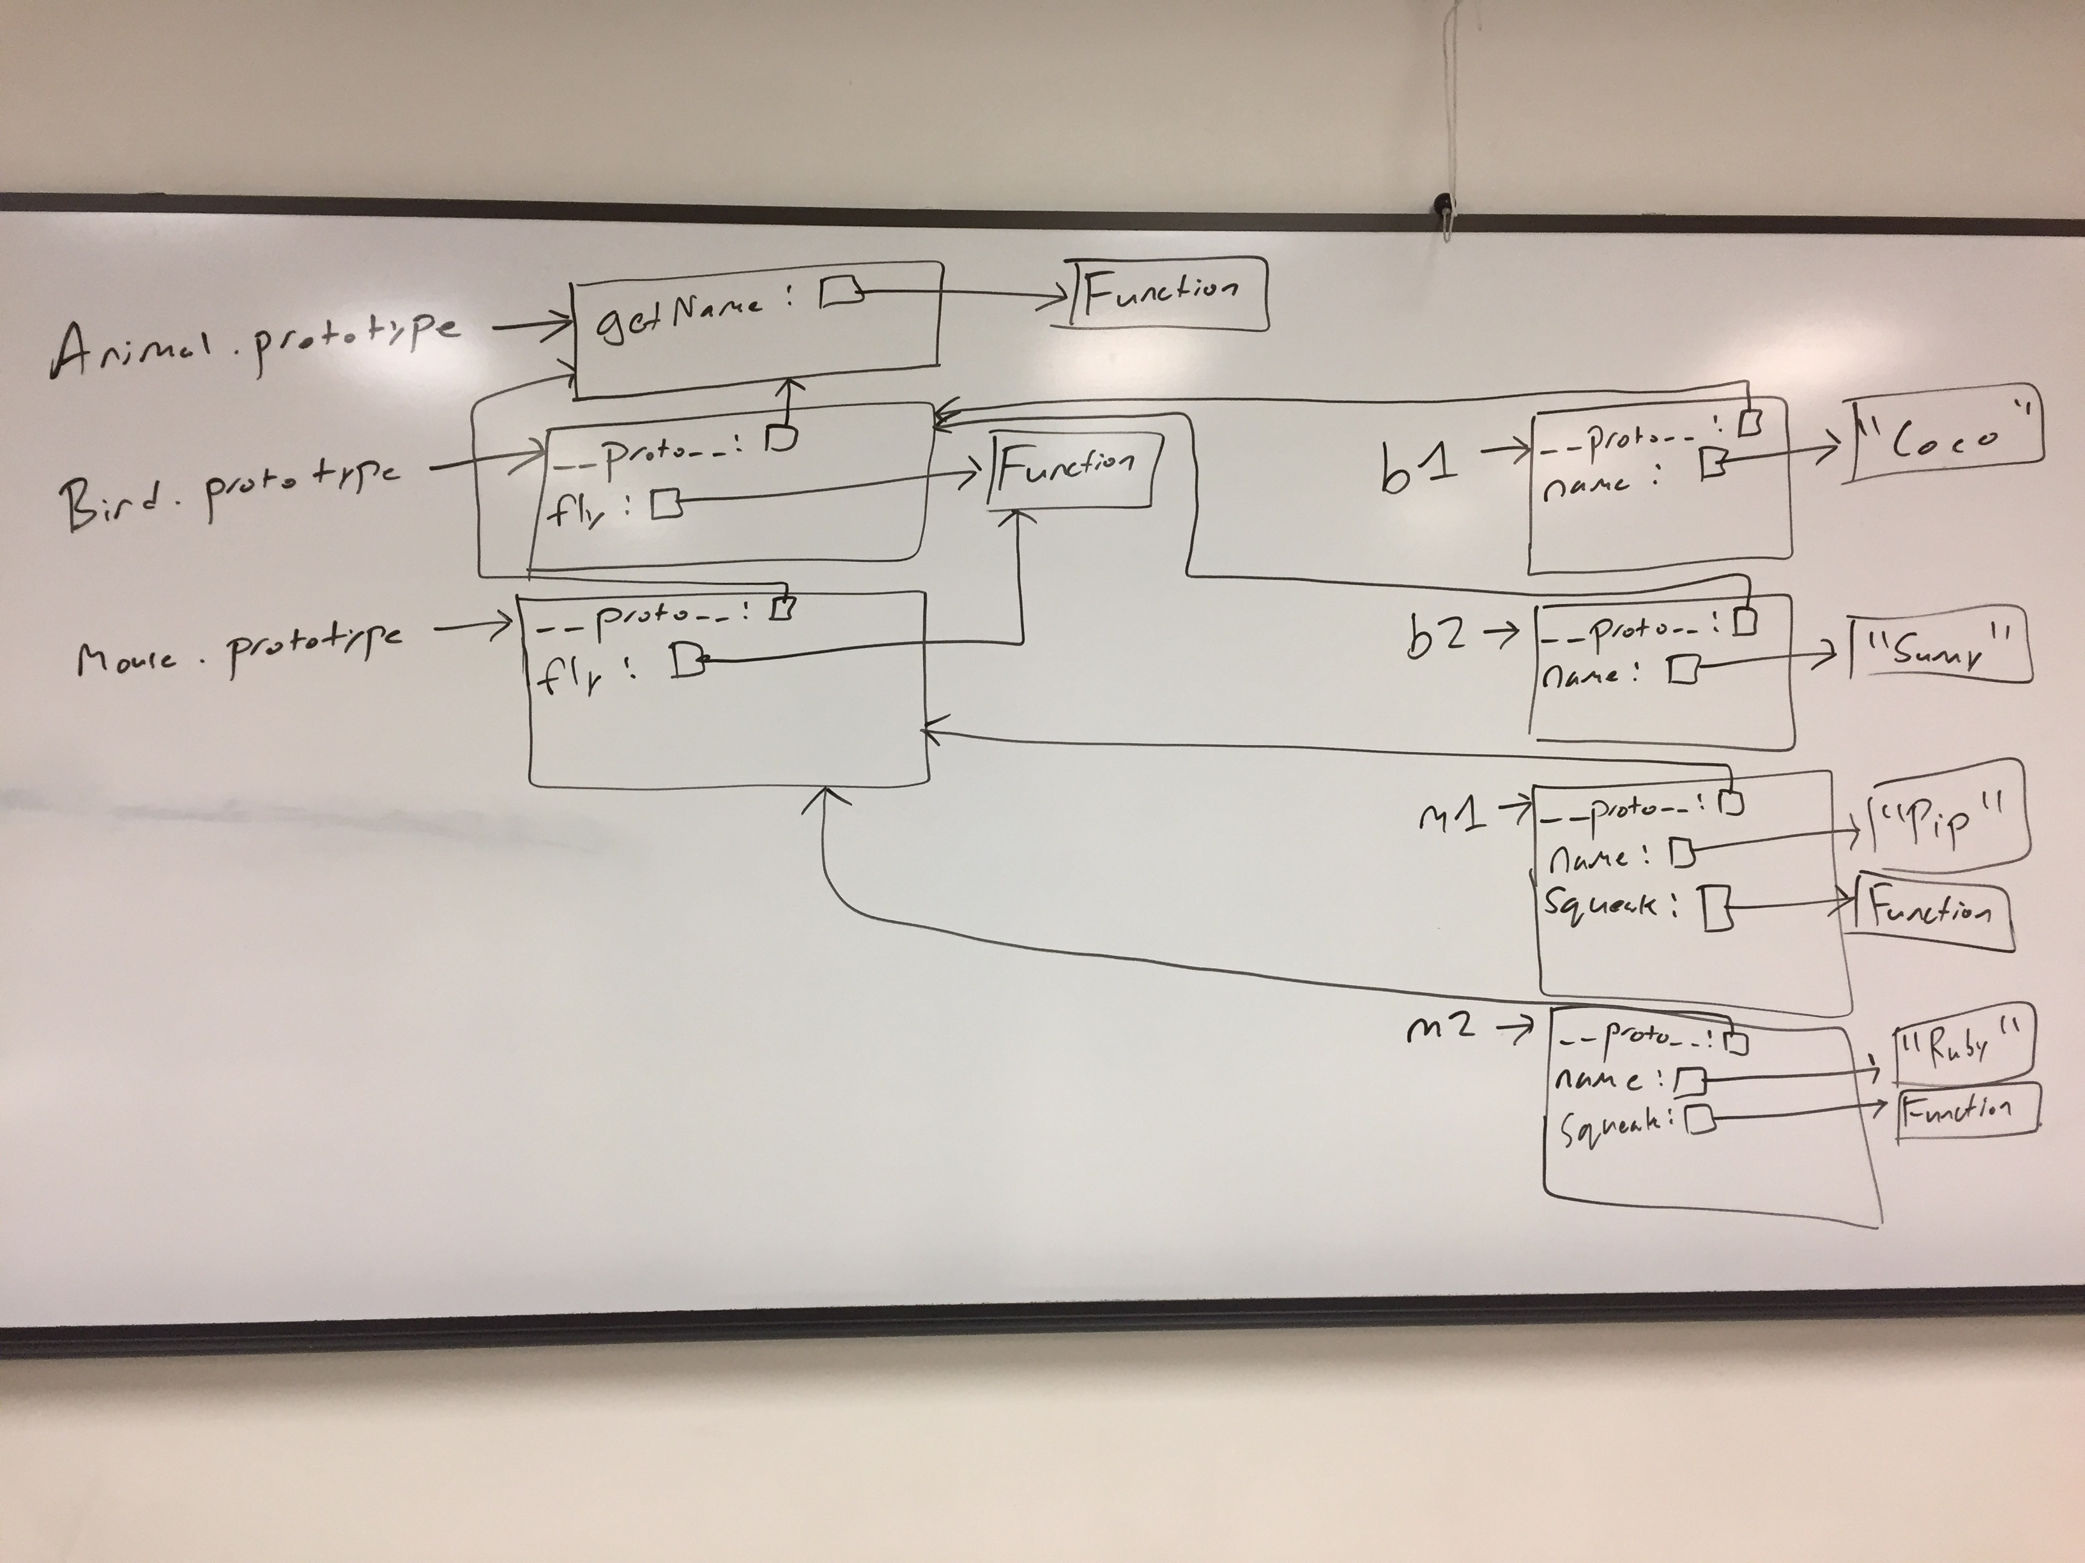
Write a memory diagram which shows how memory looks after this program executes. Your diagram should include the objects and fields associated with b1, b2, m1, m2, Mouse.prototype, and Bird.prototype, Animal.prototype. As a hint, the __proto__ field on objects refers to the corresponding object's prototype.

3.) Consider the test suite below, using assertEquals from the second assignment:

function test1() {
let t1 = new Obj("foo");
assertEquals("foo", t1.field);
}

function test2() {
let t2 = new Obj("bar");
assertEquals("barbar", t2.doubleField());
}

function test3() {
let t3 = new Obj("baz");
// hasOwnProperty returns true if the object itself has the field,
// otherwise it returns false. If the field is on the object's
// prototype instead (__proto__), it returns false.
assertEquals(false, t3.hasOwnProperty("doubleField"));
}

Write JavaScript code which will make the above tests pass.

// Object is a built-in in JavaScript, but not Obj. This requires a
// custom constructor. From test1, we know that Obj must be a
// constructor, and that Obj objects need a field named "field". The
// value of this field must be equal to whatever its parameter is.
function Obj(param) {
this.field = param;
}

// From test2, we know that we need a doubleField method on Obj
// objects. From test3, we know that doubleField cannot be directly
// on the Obj objects, so we must put it on Obj's prototype.
Obj.prototype.doubleField = function() {
// + in this context performs string concatenation; this
// concatenates this.field onto itself
return this.field + this.field;
}

Language Design / Implementation Concepts

4.) Languages which compile to machine code tend to run faster than languages which are interpreted. Provide one possible reason why.

Possible answers (non-exhaustive):
- With compiled languages, only the program itself needs to run at runtime, whereas an interpreter has overhead from the interpreter itself.
- Compiled languages allow some work to be done at compile time (e.g., typechecking), meaning less work needs to be done at runtime

5.) FooBar is a program with a C version (compiled) and a Java version (interpreted). The C and Java versions work identically and are implemented as similarly as possible.

5.a.) When FooBar is run for only a short period of time, the C version always runs faster than the Java version. Explain why this might be.

Possible answers (non-exhaustive):
- Languages that compile to machine code (like C) tend to run faster than interpreted languages.
- With machine code, right from the first instruction, you are executing your target program. With an interpreted program, the interpreter itself imparts some overhead to the program, which could potentially be worse at startup.

5.b.) When FooBar is run for a long amount of time, the Java version always runs faster than the C version. Explain why this might be.

Possible answers (non-exhaustive):
- The particular C compiler used might be generating slow machine code.
- Java has a JIT compiler, allowing it to dynamically optimize the code in ways a traditional compiler (like C) cannot do.

6.) You've been tasked to write control software for a satellite that will orbit the Earth. The software you write practically must be correct, as it will be exceedingly difficult to remotely fix bugs or reset the system. The satellite's hardware is considered very underpowered, with a processor design which is slow and multiple decades old, and a relatively small amount of available RAM. You've been given total control over the language you'll write this software in, and you've narrowed your choice of language down to C and Java.

6.a.) Provide one reason why you should use C, and one reason why you shouldn't use C.

Possible answers (non-exhaustive). Reasons to use C:
- Well-established language with plenty of available compilers, documentation, and support
- Since it compiles to machine code, there is no need to store anything other than the program on the satellite
- Being a compiled language, C will generally give better performance than an interpreted language like Java
- Since all memory management is manual, you have fine-grained control over what is allocated, where, and when, which is ideal for sticking to a small memory footprint
- The low-level nature will likely let you get every last ounce of performance from the hardware.

Reasons not to use C:
- This code needs to be correct, and more kinds of bugs are possible in C than Java thanks to undefined behavior
- C is a more permissive language than Java, so whole new classes of bugs are possible in C compared to Java

6.a.) Provide one reason why you should use Java, and one reason why you shouldn't use Java.

Possible answers (non-exhaustive). Reasons to use Java:
- Like C, it is also well-established and reaps similar benefits
- The program is presumably long running (it will run as long as the satellite is in orbit), so it could take advantage of the performance benefits the JIT compiler has to offer
- Unlike C, Java is strongly-typed, and certain classes of bugs are flat-out impossible in Java as a result (which is good for writing correct code)

Reasons not to use Java:
- Since Java is interpreted, it has a runtime interpreter that must be put on the satellite along with the program, taking up precious room
- Similarly, the interpreter itself will impart some runtime overhead, and processor cycles are already in short supply
- Since Java's garbage collected, it likely won't be as efficient with memory as the C version could be
- Java's garbage collector could kick in at an inopportune time, causing delays during critical moments (e.g., firing thrusters)

7.) Both reference counting and garbage collection are systems used to automatically reclaim memory that is no longer in use. However, reference counted systems may additionally have a garbage collector available (e.g., Python). Why would a reference-counted system additionally need a garbage collector?

Reference counting alone cannot reclaim cyclic data structures, which will leak memory when they are no longer needed. Garbage collection can reclaim these structures.

Pattern Matching in Swift
(Note: this might not be on the exam, depending on how far we get Tuesday.)

8.) Consider the following enum definition:

enum SomeEnum {
case foo(Int)
case bar(Int, Int)
case baz(Int, Int, Int)
}

Write a function named test which takes a value of type SomeEnum. The function should do the following:
- If given a foo, it should return the value in the foo
- If given a bar, it should return the sum of the two values in the bar
- If given a baz, it should return the sum of the first and last values in the baz. You should not introduce a variable for the second (middle) value in the baz.

An example call to the function follows: test(SomeEnum.baz(1, 2, 3))

func test(_ value: SomeEnum) -> Int {
switch value {
case .foo(let x):
return x
case .bar(let x, let y):
return x + y
case .baz(let x, _, let y):
return x + y
}
}

Generics and Higher-Order Functions in Swift
(Note: this might not be on the exam, depending on how far we get Tuesday.)

9.) Write the body of the following function, or say if it's impossible to implement. If it's impossible to implement, explain why.

func combine<A, B>(a: A, b: B) -> (A, B) {
return (a, b)

}

10.) Write the body of the following function, or say if it's impossible to implement. If it's impossible to implement, explain why.

func combine2<A, B>(a: A) -> ((B) -> (A, B)) {
return { b in (a, b) }

}

11.) Write the body of the following function, or say if it's impossible to implement. If it's impossible to implement, explain why.

func combine3<A, B>(tup: (A, B)) -> A {
let (a, _) = tup
return a

}

12.) Write the body of the following function, or say if it's impossible to implement. If it's impossible to implement, explain why.

func combine4<A, B>(a: A, f: (A) -> B) -> (A, B) {
return (a, f(a))

}
13.) Consider the following enum definition:

enum Something<A, B, C> {
case alpha(A)
case beta(B)
case gamma(C)
}

13.a.) Write the body of the following function, or say if it's impossible to implement. If it's impossible to implement, explain why.

func combine5<A, B, C>(s: Something<A, B, C>) -> (A, B, C) {
Impossible to implement. s holds one of an A, B, or C, and the return type requires all three

}

13.b.) Write the body of the following function, or say if it's impossible to implement. If it's impossible to implement, explain why.

func combine6<A>(s: Something<A, A, A>) -> A {
switch s {
case .alpha(let a): return a
case .beta(let a): return a
case .gamma(let a): return a
}

}

14.) Write the body of the following function, or say if it's impossible to implement. If it's impossible to implement, explain why.

func combine7<A, B>(f: (A) -> B, b: B) -> A {
Impossible to implement. f needs an A, but we only have a B.

}

