COMP 410
Fall 2022
Midterm Practice Exam #1 (Solutions)

Abstract Syntax Trees

In Boolean expressions, ¬ has the highest precedence, followed by ∧ and ∨. With this in mind, write out the ASTs corresponding to each of the following Boolean expressions:

1.) ¬a ∧ b ∨ c
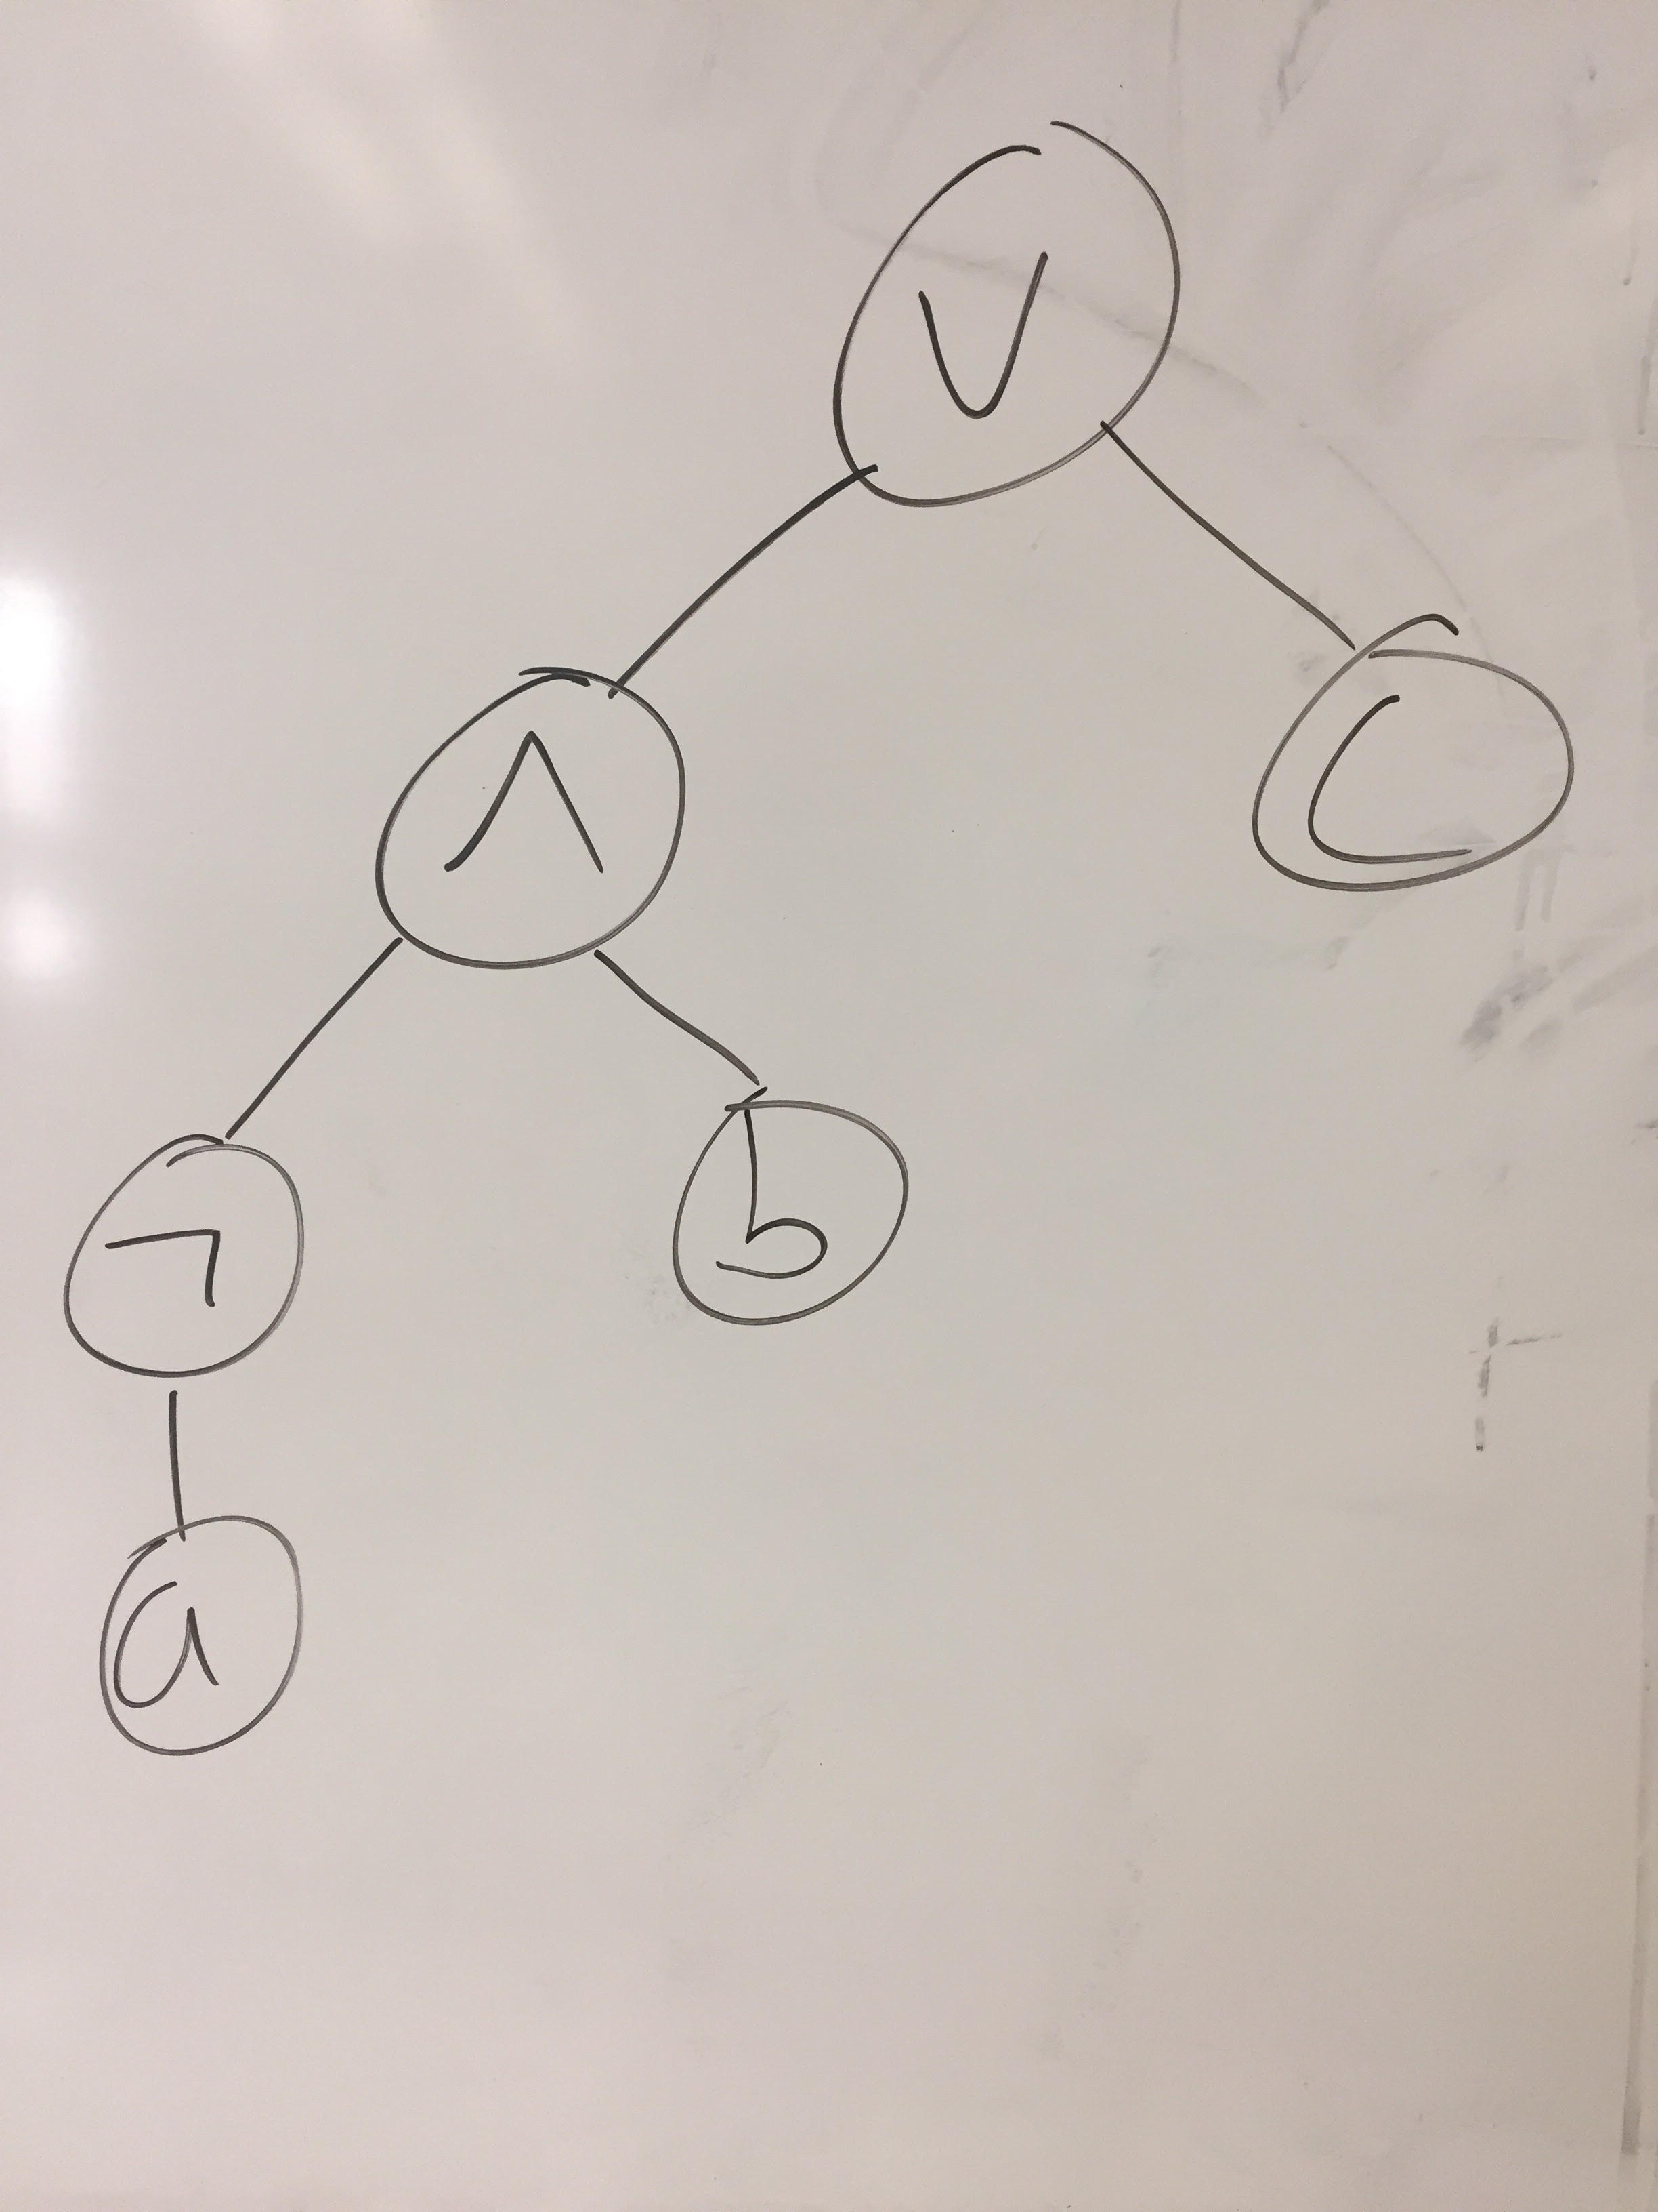

2.) (a ∨ b) ∧ c

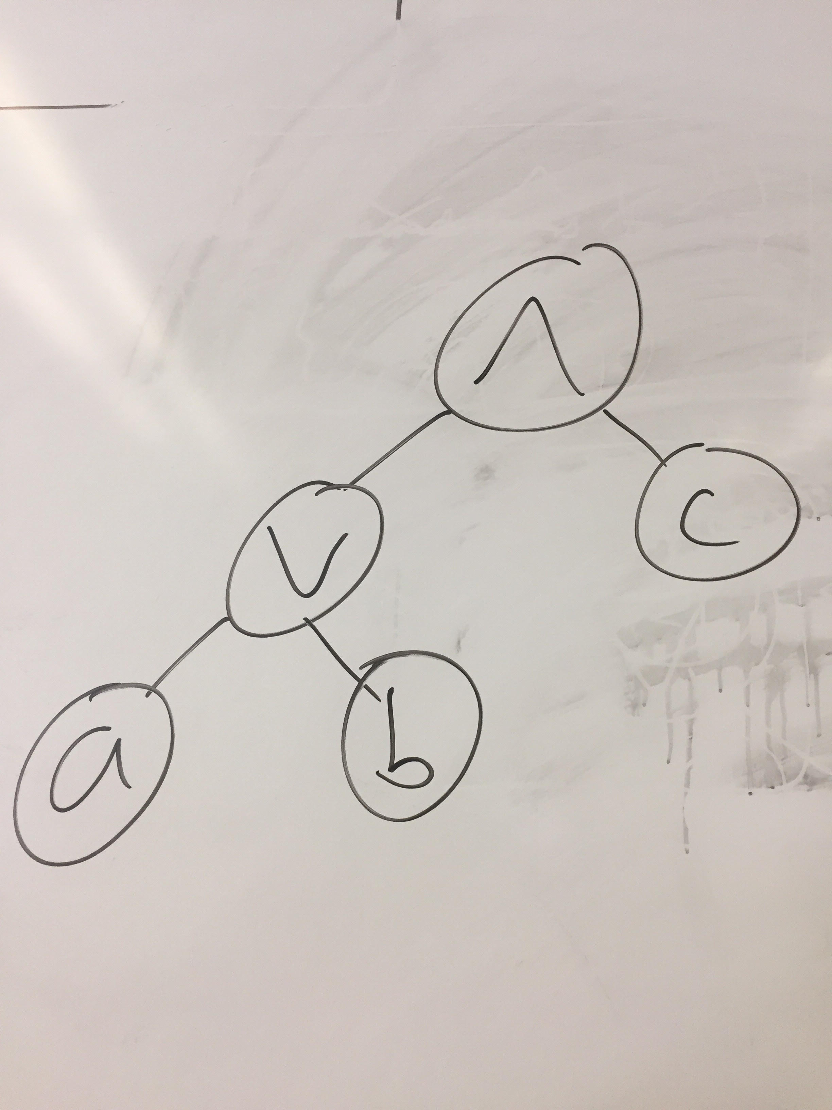

3.) ¬(a ∧ b) ∧ (b ∨ c)

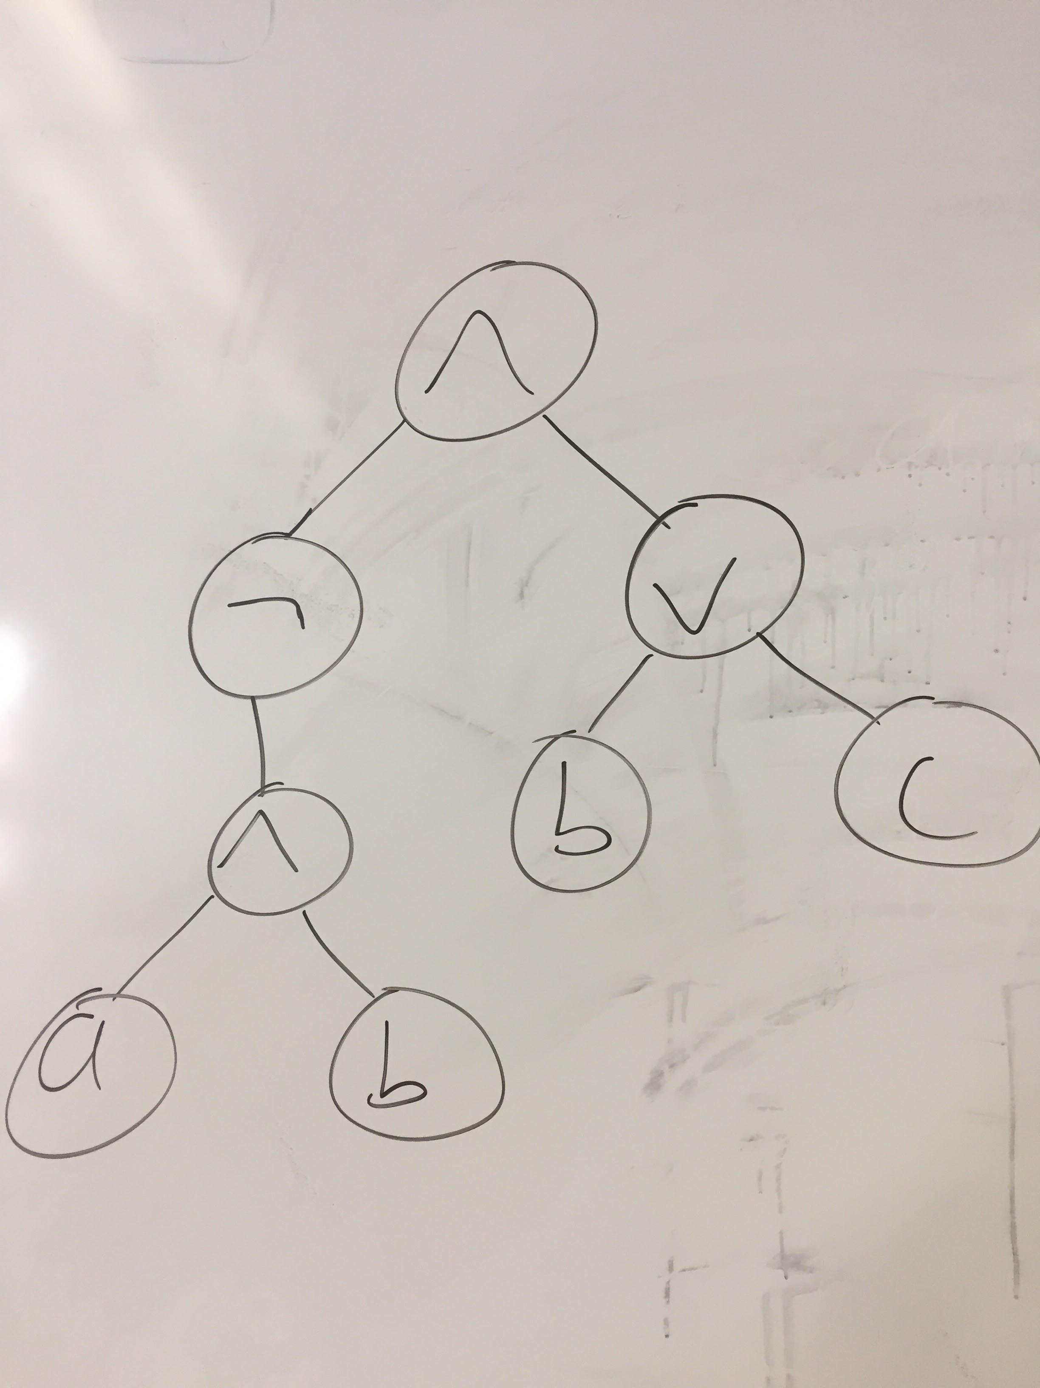

Arithmetic expressions can be used to form Boolean expressions with the help of arithmetic comparisons (e.g., <, <=, >, >=, ==). These comparisons have the lowest possible precedence. With this in mind, write out the ASTs corresponding to each of the following expressions:

4.) 1 * 2 + 3 == 4

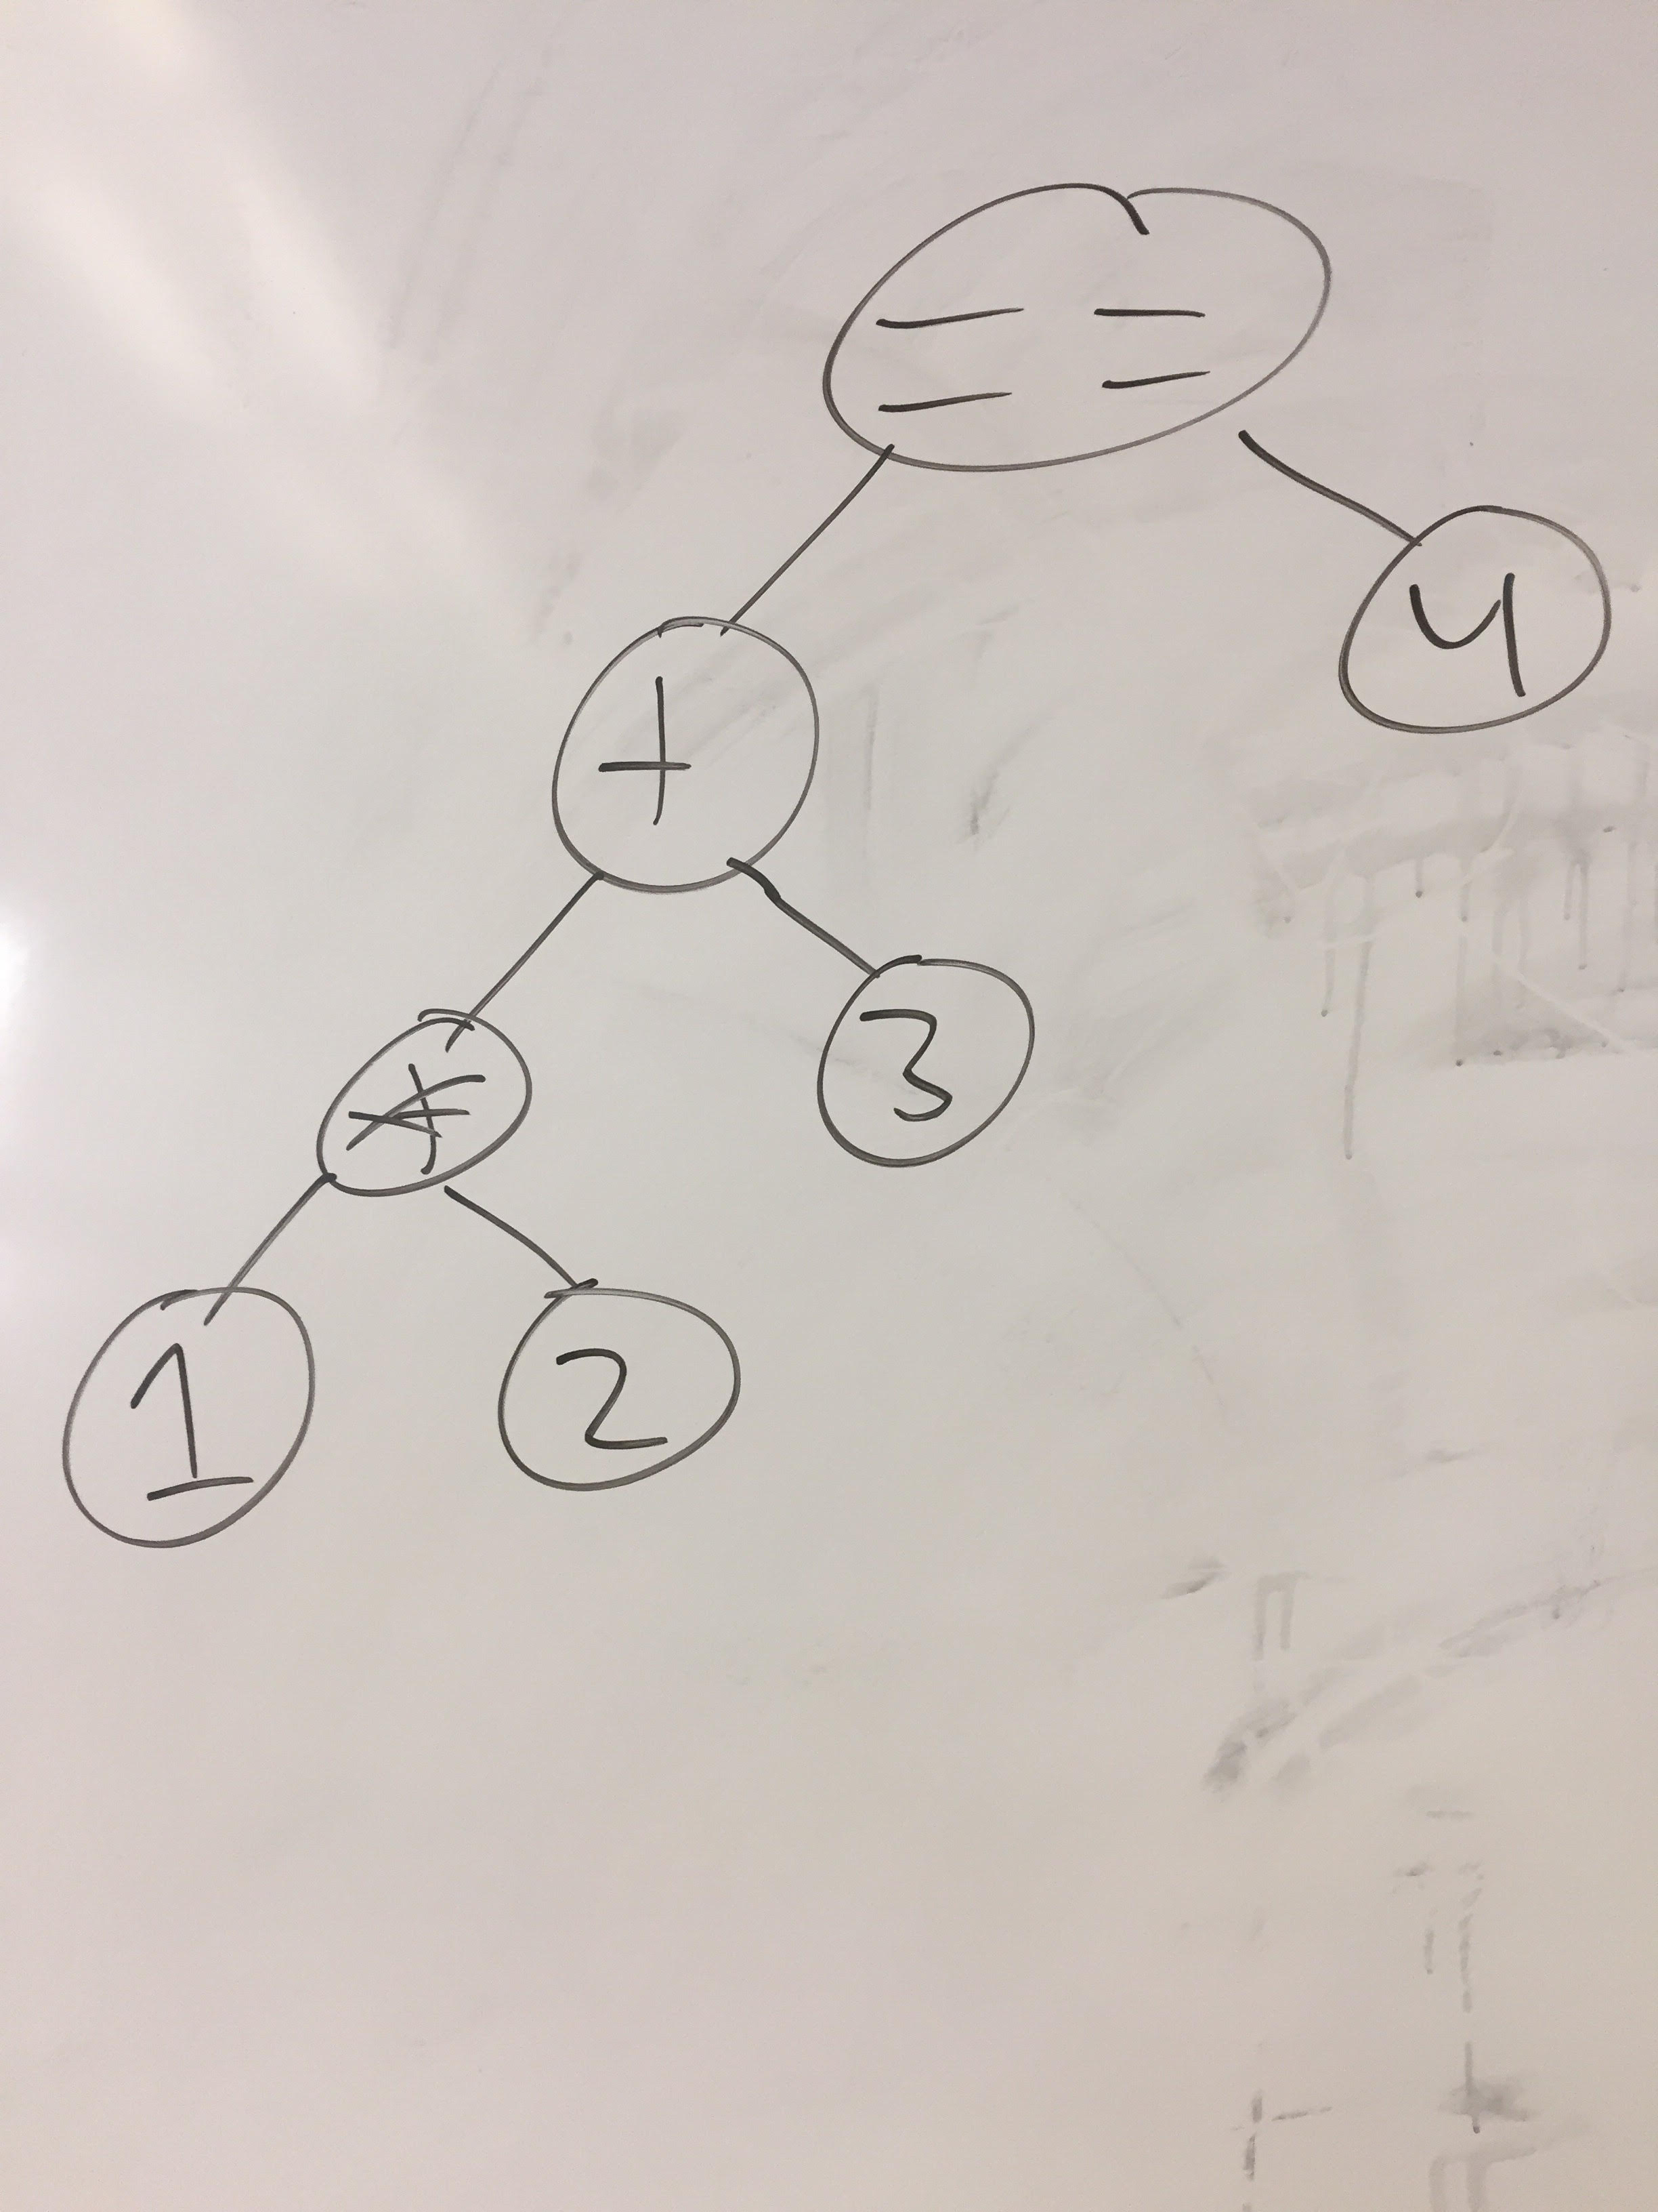

5.) (2 + 2 < 4) ∧ ¬a

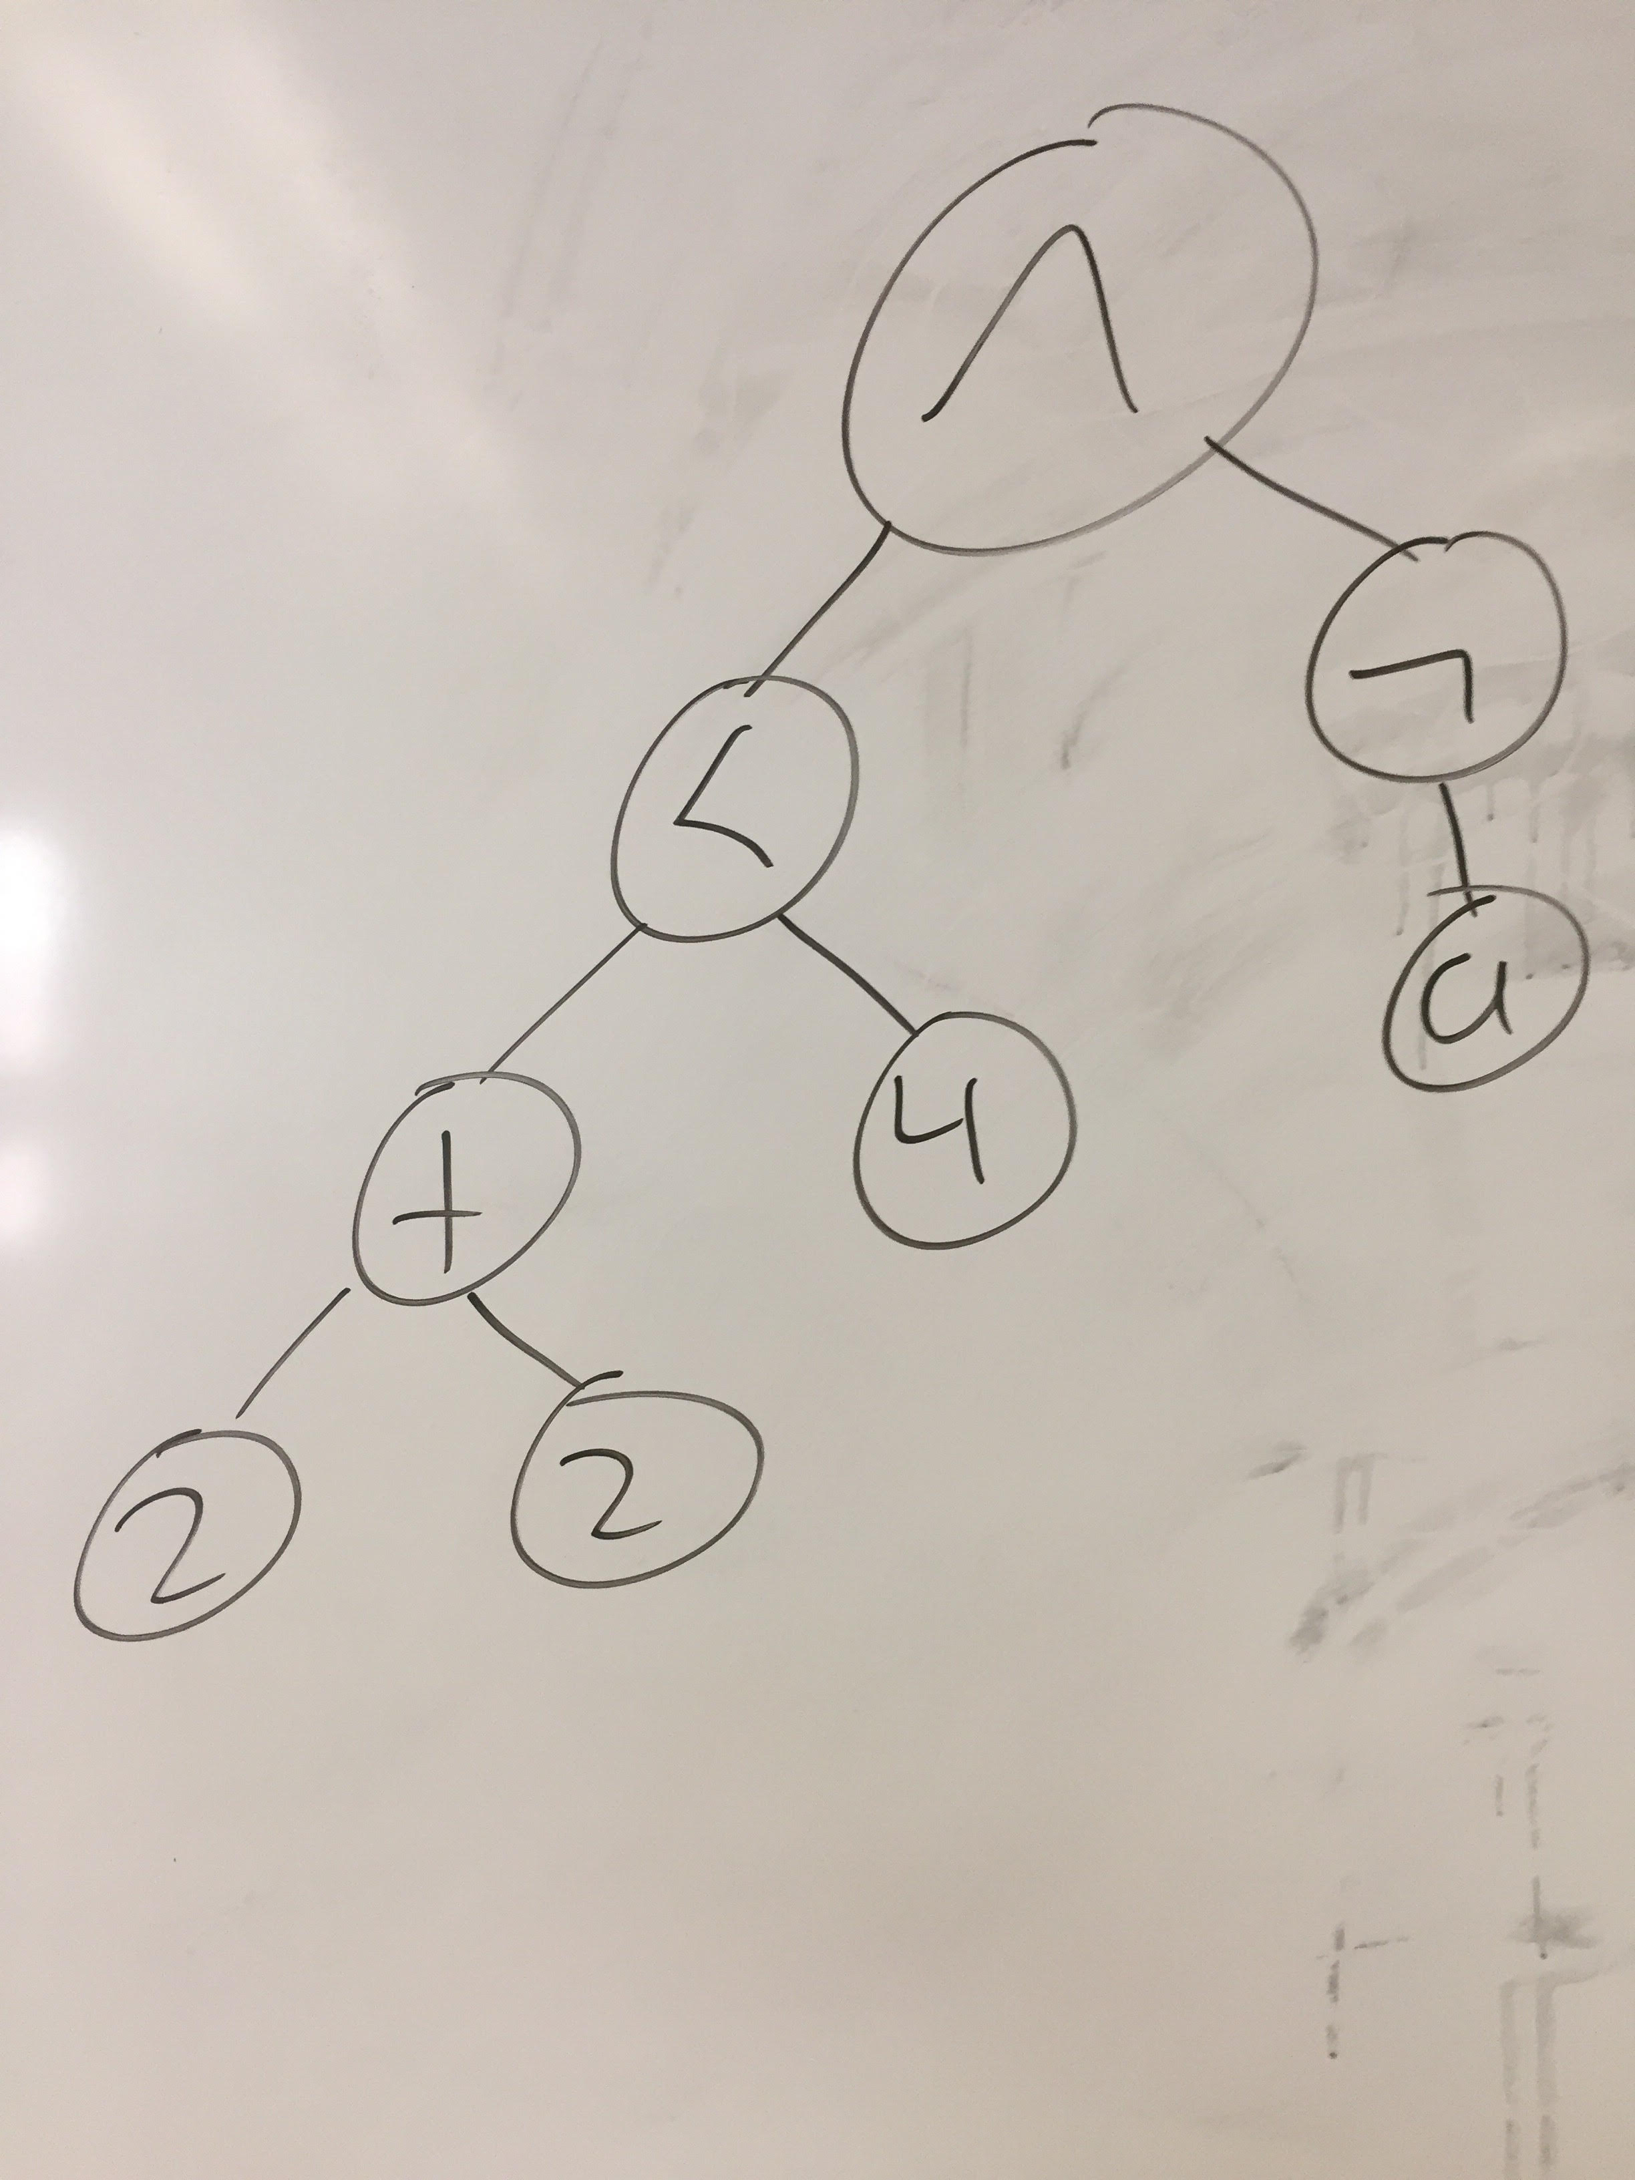

6.) Consider the following Python class definitions, which are adapted from assignment 1's boolean evaluator. These classes are used to represent AST nodes.

class And:
def __init__(self, left, right):
self.left = left
self.right = right

class Or:
def __init__(self, left, right):
self.left = left
self.right = right

Assume that Boolean true is represented as an AST with Python's True, and Boolean false is represented as an AST with Python's False. With all this in mind, represent the following Boolean expressions in Python using And, Or, True, and False as appropriate.

6.a) true ∧ false

And(True, False)

6.b.) false ∨ true

Or(False, True)

6.c.) false ∧ true ∨ true

Or(And(False, True), True)

6.d.) false ∨ true ∧ true

Or(False, And(True, True))

Semantic Tableau

For each of the following Boolean formulas, write out the complete semantic tableau tree. Circle the nodes in the tree representing solutions. If a tree has no solutions, say so. Be sure to write all steps.

7.) ¬a ∧ a

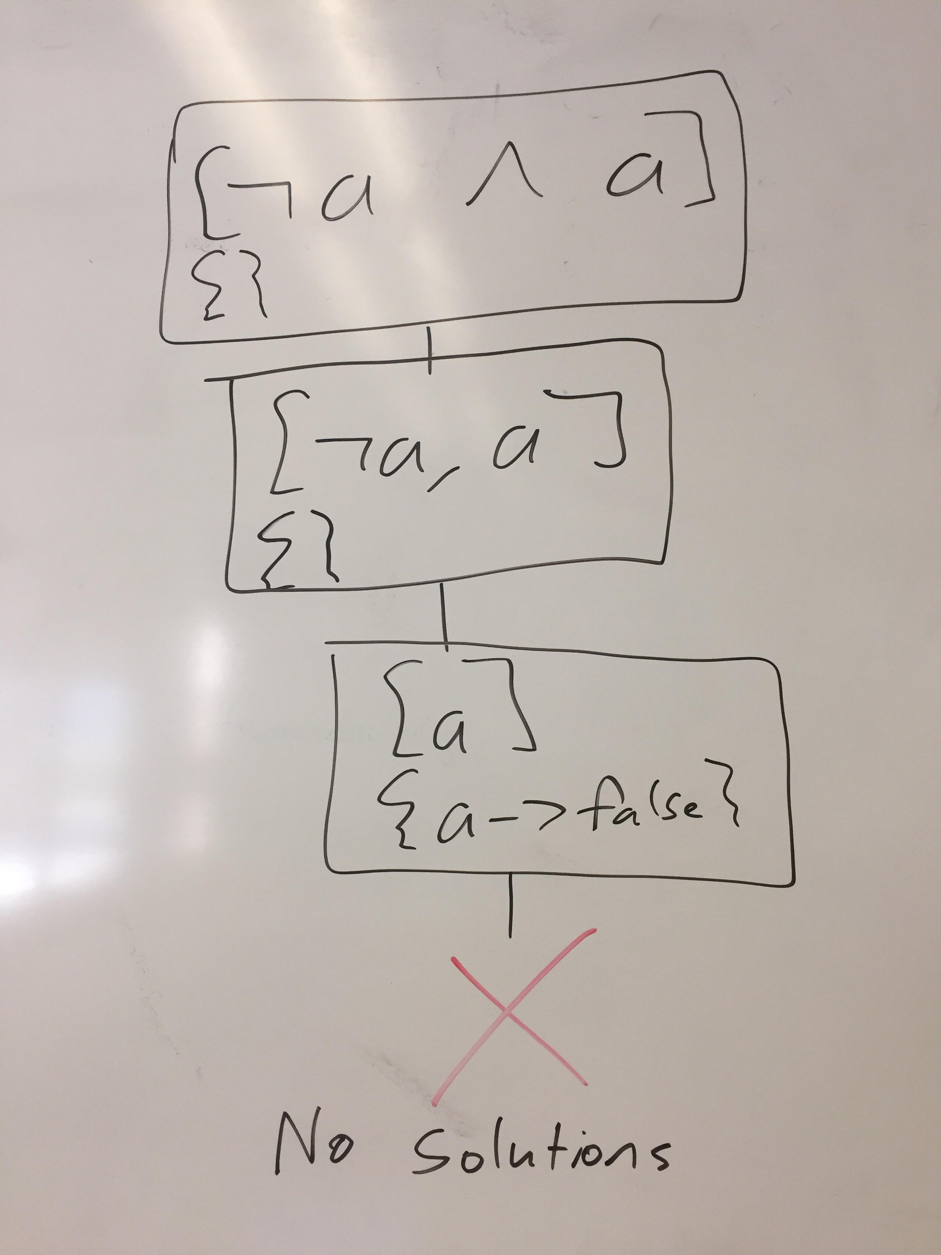

8.) (a ∨ ¬a) ∧ a

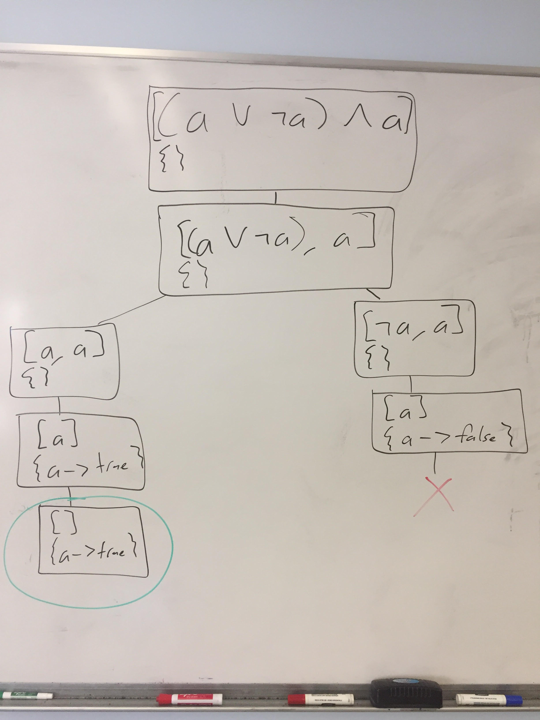

9.) (¬x ∧ ¬y) ∨ (x ∧ y)

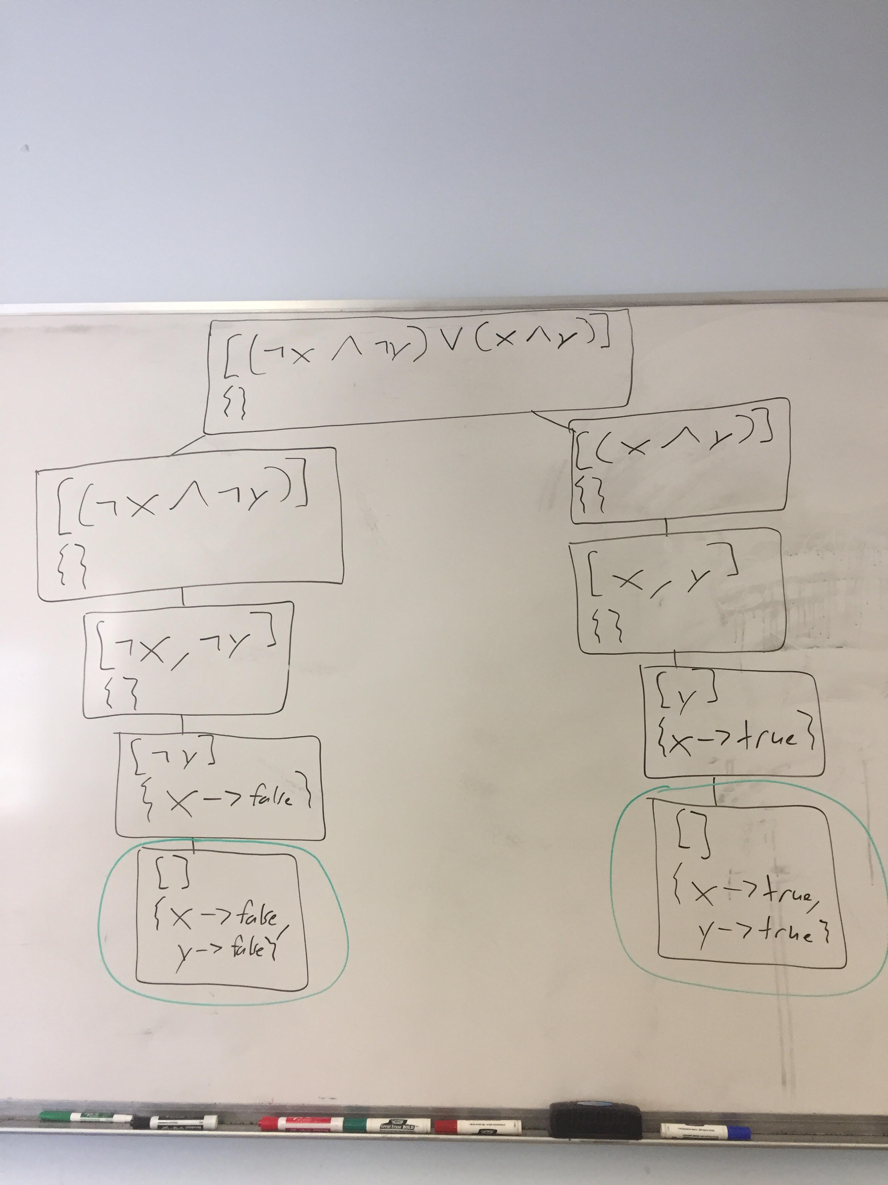

Prolog - Modeling the World

10.a)
For this problem, you need to write a clause database encapsulating pricing information for a convenience store. Write Prolog code accurately reflecting the following:

- Soda costs $2
- Chips cost $3
- Hot dogs cost twice as much as soda (do not hardcode $4)
- Soda chips, and hot dogs are food
- Pencils and pens are office supplies
- All office supplies cost $2
- Cold medicine costs $7

% all facts and rules with the same name should be placed
% together in the file
cost(soda, 2).
cost(chips, 3).
cost(hot_dog, Cost) :-
cost(soda, SodaCost),
Cost is SodaCost * 2.
cost(OS, 2) :-
office_supplies(OS).
cost(cold_medicine, 7).

food(soda).
food(chips).
food(hot_dog).

office_supplies(pencil).
office_supplies(pen).

Using the clause database you previously wrote, write queries to determine the following:

10.b.) Which items cost exactly $2?

?- cost(Item, 2).

10.c.) Which items cost more than $3?

?- cost(Item, Cost), Cost > 3.

10.d.) Which foods cost less than $3?

?- food(Food), cost(Food, Cost), Cost < 3.

10.e.) Which foods are also office supplies?

?- food(Item), office_supplies(Item).

Unification

Consider each of the following unification attempts. If the unification succeeds, record any values any variables take. If the unification fails, say so.

11.) foo(1, X) = foo(Y, 2)

X = 2, Y = 1

12.) foo(1, X) = foo(X, 2)

false

13.) foo(1, _) = foo(X, 2)

X = 1

14.) foo(1, _) = foo(1, _)

true

15.) foo(1, 2, bar) = foo(X, _, _, _)

false

16.) foo(bar(baz), X) = foo(Y, Z), Y = bar(A)

X = Z, Y = bar(baz), A = baz

